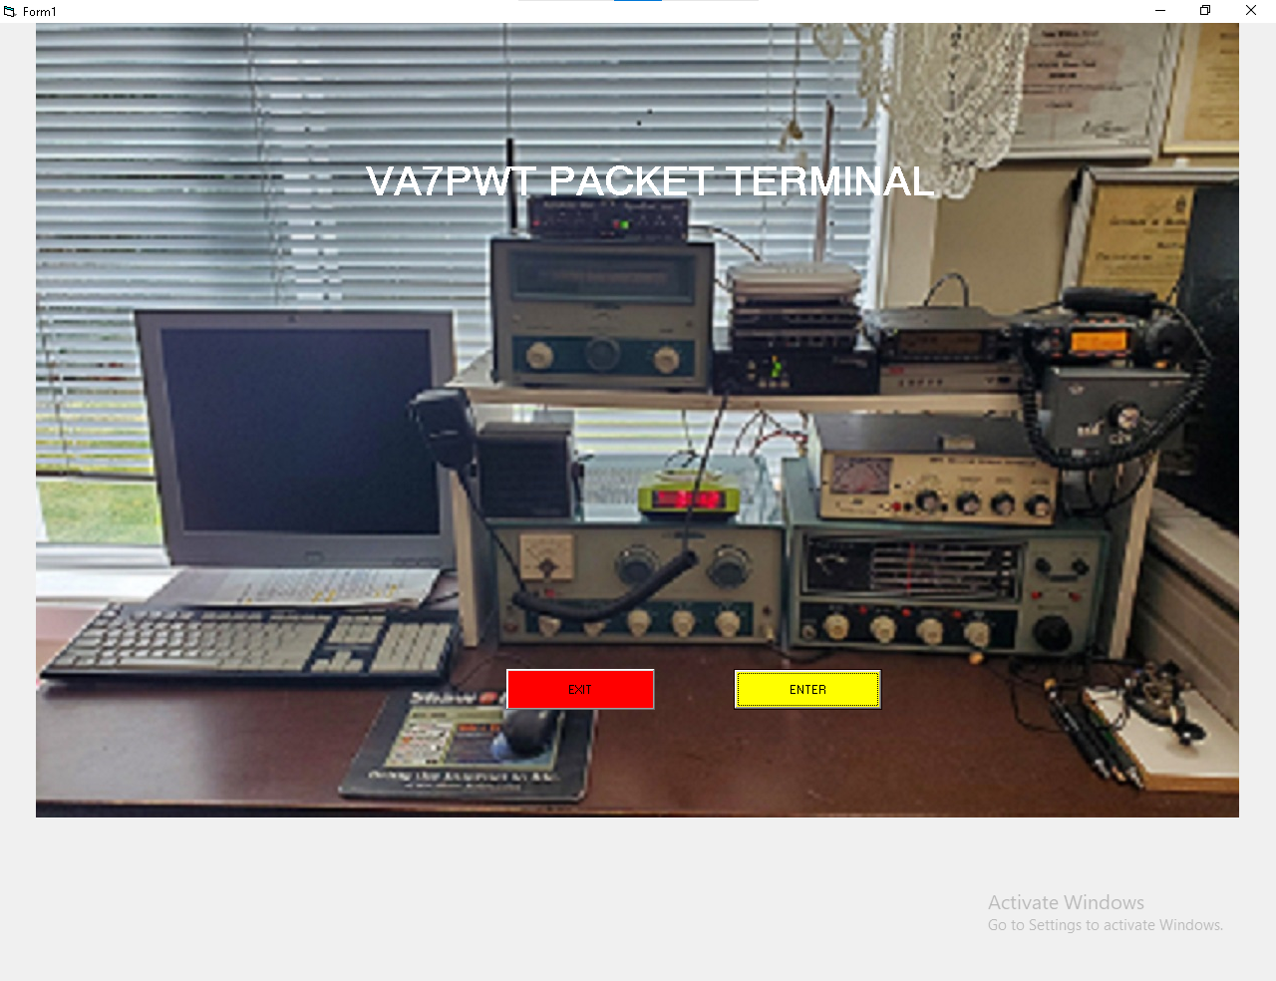
VA7PWT PACKET TERMINAL PROGRAM
Click Enter to Start
TERter

Main Form
Each box is showing what will show once you have finished the setup.
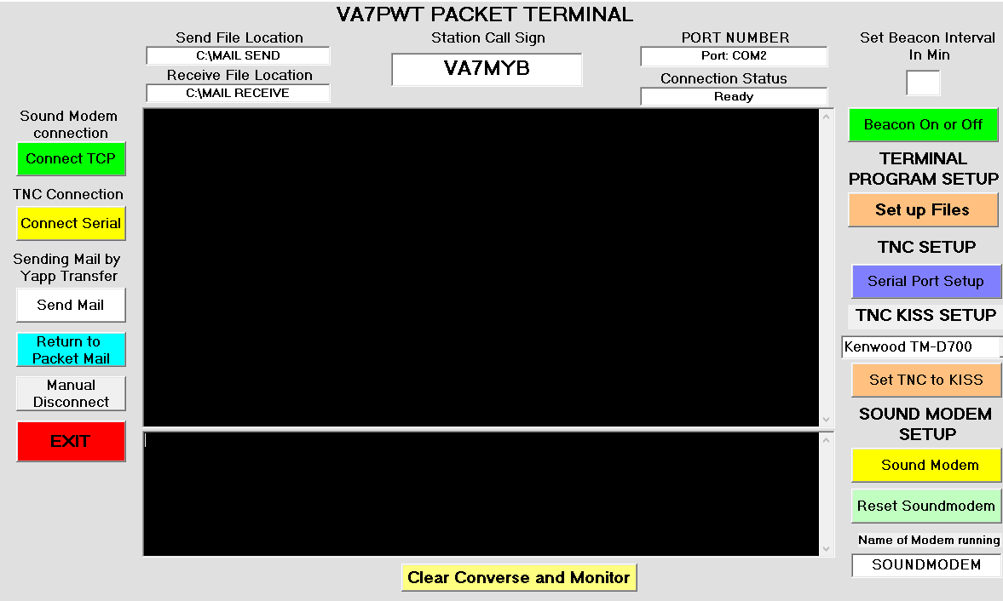
- Click on Set up Files.

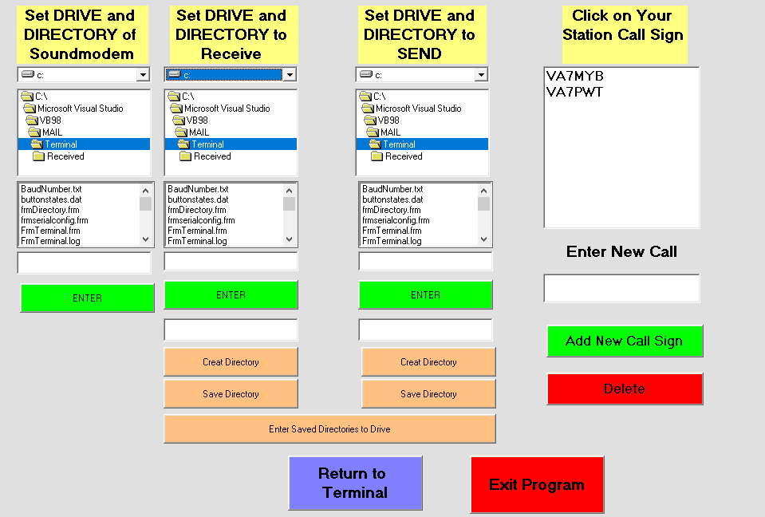
File Setup Screen
- Set up Receive file- ensure C:\ is highlighted in blue.
- Double Click on drive to ensure it is C:\
- If this is first time, then you need to make the directory.
- Just below green enter (type Mail Receive), click create directory then click save directory.
- Repeat same for Send directory. (Type Mail Send)
- Click Saved Directories to Drive
- Go to Receive Directory. Double Click on C:\
- Scroll down until you see Mail Receive, double click to highlight it
- Click the green Enter button
- Repeat for the send Directory Look for Mail Send
- Enter The Call Sign of the station you want this to be in the Enter New Call
- Click Add New Call Sign
- It will show in the top box. Double click on it

At this time you can set up the sound modem or just go back to main Terminal. I will explain the sound modem later on.

Next we will set up Serial Port. Only required if using a regular TNC not a sound modem
Serial Port Setup
Only required if using a TNC not Sound Modem

- Click on Serial Port Setup
- Pick Port Number your TNC is connected. If not sure open Device Manager and look for com ports. There you will see what com port your tnc is connected to.
- Use the Drop down box, locate your com port and double click on it
- Pick your Baud rate for your TNC. Common Baud Rates for example Kantronic TNC is 1200 baud.
- Double click on your selected Baud Rate
- Then Click on the Start button
NOTE
With the Serial Style TNC you have to place it in Kiss Mode. On the next page I will show you how.
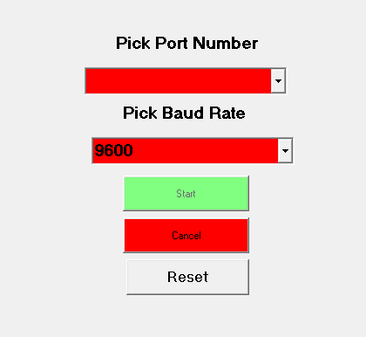

Setting up TNC into KISS MODE
Kiss mode is normally required to connect to most BBS boards, Winlink, other terminals. It is required for my Terminal to Terminal and use of my Packet mail Program.
- Using the scroll down text box Scroll down to find your TNC Model. I have included the more common ones. If not found then you may have to use a simple terminal to set your TNC settings. The Kantronic listed is good for all versions.
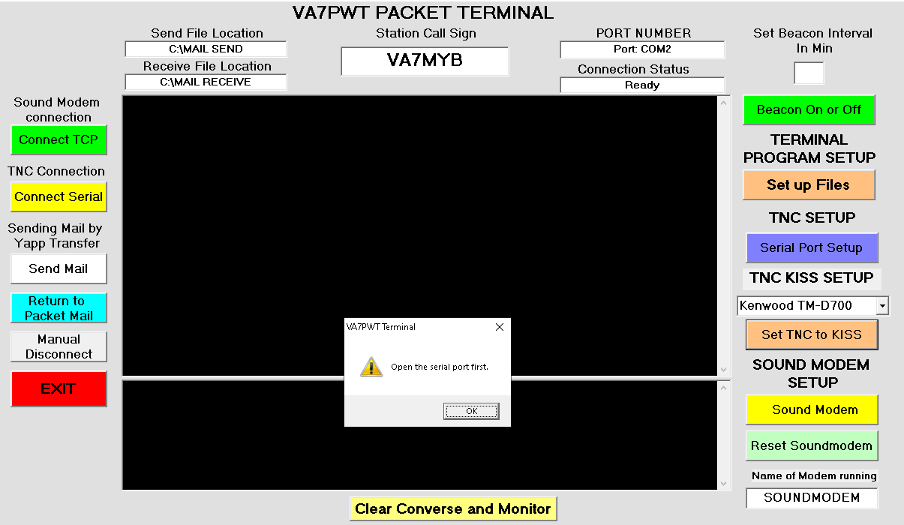
- Important , YOU MUST HAVE THE SERIAL TNC STARTED OR YOU WILL GET THIS MESSAGE

- Once you have Connect Serial Activated click on

- The Kiss will be started. You will get a notice like the following in the convers screen for your type of TNC
- cmd:
*** Kantronics KPC Series switched to KISS mode
- You then can connect to stations
Sound Modem Setup

- Open the SET UP FILES
- In the Set Drive and Directory of Soundmodem ensure C:\ drive is highlighted. Double click on it
- Scroll down until you see the soundmodem program you wish to use. (EX Soundmodem or Direwolf)
- Ensure it is highlighted then double click on it
- In the file look for the .EXE file and highlight it.

- Click on the Enter button. This will cause the text box to show you have excepted the directory and .exe file

- Return to Terminal

- Before you can use the Connect TCP you must have your Sound Modem running.
- To start your Sound Modem just click on the Sound Modem Button
- Once you started the sound modem you decided on, it should show in the text Box labelled Name of Modem Running.
- You can now click on the Connect TCP Button. It should show
*** Opening TCP KISS port...
*** TCP connected
cmd:
5.In the Port Number Text box it will show the port Number of 8100 and in the Connection Status Text box it will say Ready

Other Command Buttons
Send Mail- You click on this when you have a Packet Mail Message to send.
- Connect to a station first
- Click on Send Mail
- This box will open. Pick the file you wish to send, then click on open
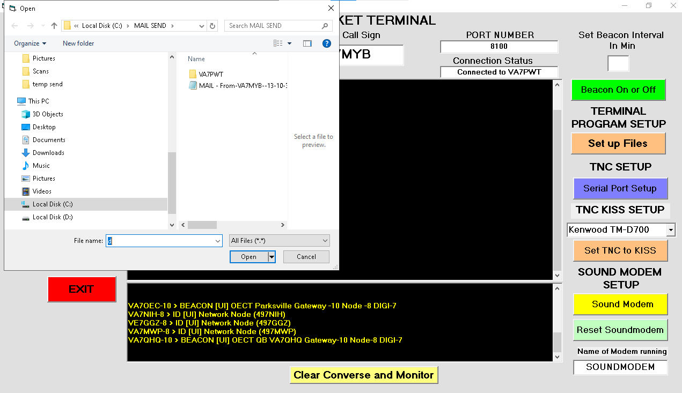
- This will start the automatic sending of the message. A box will open showing the transfer taking place, as soon as the message has been sent you will see a message something below. This is a message I sent as you can see.
*** YAPP sending: MAIL - From-Peter--08-44-01--05-26-26.dat (286 bytes)
*** YAPP complete: MAIL - From-Peter--08-44-01--05-26-26.dat
cmd:

- When the CMD: prompt shows disconnect from the other station. This is to stay in line with other terminals that send yapp files.

If you have any questions or concerns please contact myself Peter Tryon ptryon2@gmail.com
Thank you

